Question 1: (a)
Only Admins should be allowed to change the account owner.
Error Message : "You are not authorised to transfer the account." (5 marks)

- I wrote the following validation rule.
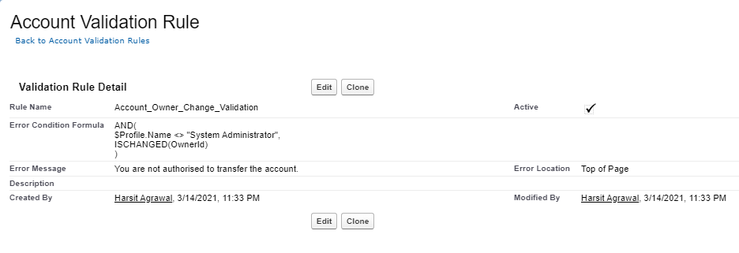
Validation Formula is as follows:
AND(
$Profile.Name <> "System Administrator",
ISCHANGED(OwnerId)
)

Question 1: (b)
While closing the opportunity ( 'Closed Won') , an Opportunity Line Item should be present. If opportunity line item is not present under a opportunity ,
it should give the error message "Opportunity Line Item should be present while closing the opportunity." (10 Marks)

- Firstly I created a roll up summary field to count the number of Opportunity Products on the Opportunity created. (API Name: Product_Count__c )
- Then I wrote a validation on the Opportunity object.
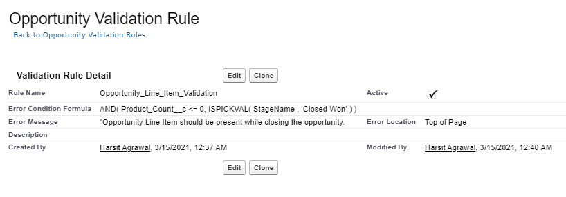
- Validation formula is:
AND( Product_Count__c <= 0,
ISPICKVAL( StageName , 'Closed Won' )
)

Question 2:
Workflow Rule (5 Marks)
If Amount > $10,000 send an email alert on opportunity closed won (Stage field value) to pgoyal@kloudrac.com and msharma@kloudrac.com

Email Template .

Subject : Deal closed Alert - $Amount - Opportunity Name

Opportunity Name :
Account Name :
Account Owner :
Amount :
Close Date :

Best Regards
Salesforce Team - Kloudrac

- First I created an Email Template in salesforce classic.
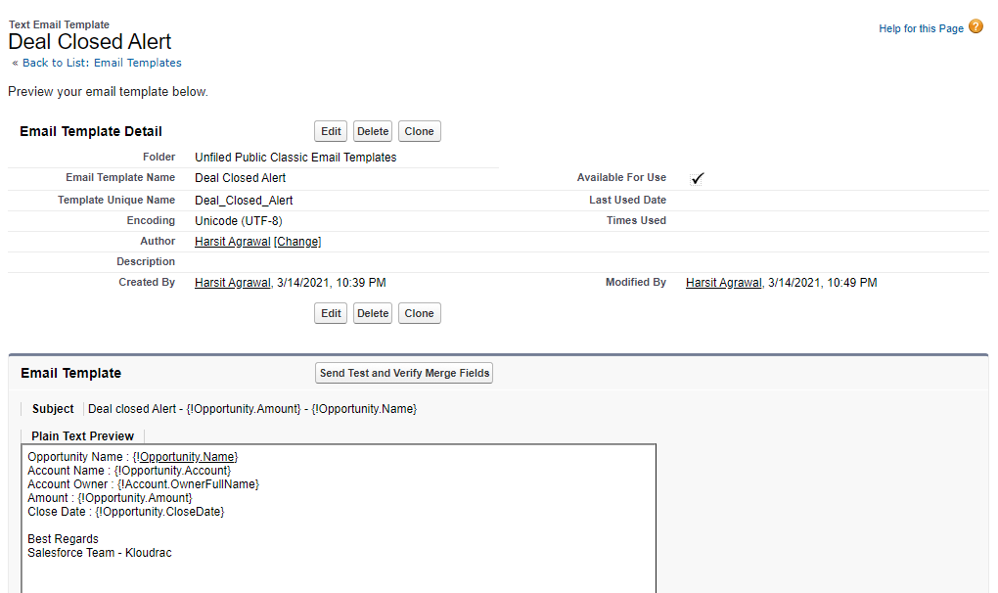
- Then I write a workflow rule.
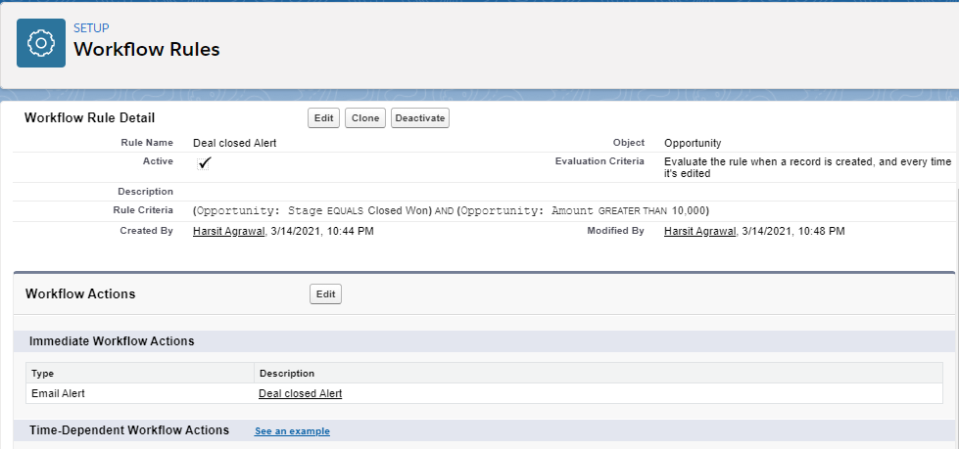

- And then a workflow action.
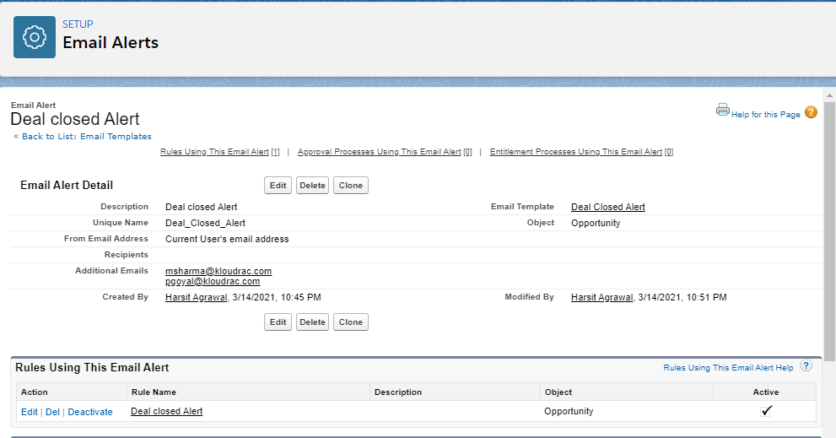

Question 3:
Process Builder (10 Marks)
Kloudrac Softwares would like to set up a process where an event will get created on opportunity creation and an automated approval will go to the opportunity owner's manager whenever discount > 20% on opportunity.

There is a field Discount, Approval Status on Opportunity.
Default value for Discount - "Approval Not Required".
When Discount is greater than your allowed matrix - "Approval Required"
When submitted for approval - "Approval Pending"
When Approved / Rejected - "Approved / Rejected”

- Firstly I created two custom fields for discount and approval and then I wrote an Approval Process.
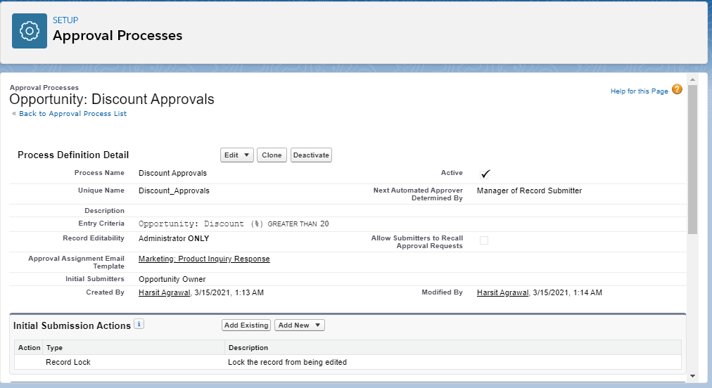
- Then I wrote a process builder.
Criteria:
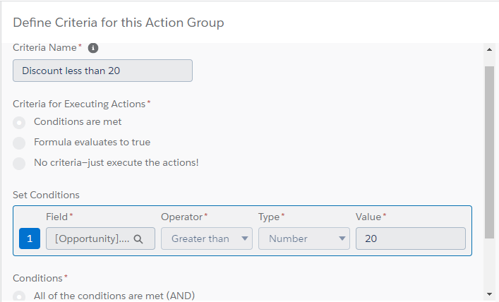
Immediate Action:
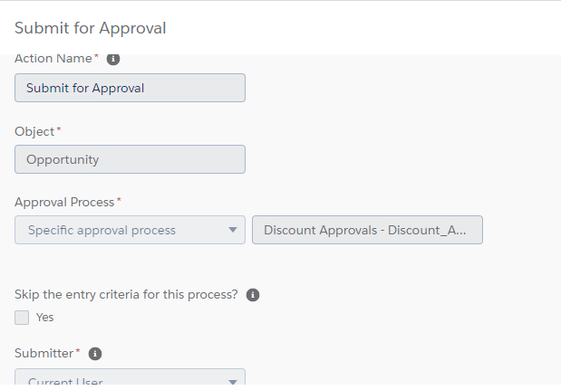

Trigger (2)
trigger OpportunityProduct on Opportunity (After update) {
List<Opportunity> opp = new List<Opportunity>();
Pricebook2 standardBook = [SELECT Id FROM Pricebook2 WHERE IsStandard = true];
List<OpportunityLineItem> lines = new List<OpportunityLineItem>();
PricebookEntry entry = [SELECT Id, UnitPrice FROM PricebookEntry WHERE Pricebook2Id = :standardBook.Id AND Product2.ProductCode = 'DEFAULT'];
for(Opportunity eachOpp:Trigger.New){
lines.add(new OpportunityLineItem(PricebookEntryId=entry.Id, OpportunityId=eachOpp.Id, UnitPrice=entry.UnitPrice, Quantity=1));
insert lines;
}
}

Trigger (3)
trigger AutoCreateQuoteAndQuoteLineItem on Opportunity (after insert) {
for(Opportunity eachOpp: Trigger.new){
List <Quote> getQuote = new List <Quote> ();
List <QuoteLineItem> getQLI = new List <QuoteLineItem> ();

if (eachOpp.Amount > 100000){

Quote objQuote = new Quote(Name = 'Harsh', OpportunityId = eachOpp.Name);
getQuote.add(objQuote);

QuoteLineItem objQLI = new QuoteLineItem(QuoteId = objQuote.Name);
getQLI.add(objQLI);
}
insert getQuote;
insert getQLI;
}
}

